John Snow and the London Cholera Epidemic of 1854
John Snow was an anaesthesiologist practicing in London during 19th century. In 1849, he published "On the Mode of Communication of Cholera" in which he proposed that cholera was spread through the contamination of food or water. At the time, this was one of a number of competing theories about the transmission of cholera - none of which had strong evidence-based support.
During the 1854 epidemic of cholera in England, Snow had an opportunity to test his hypothesis. First, he compared two major water companies in London (Southwark and Vauxhall, Lambeth) and found that more cholera deaths occurred among those who obtained their water from the Southwark and Vauxhall company (315 deaths per 10,000 houses) than the Lambeth company (38 deaths per 10,000 houses). Interestingly, only the Southwark and Vauxhall company drew its water from the lower part of the Thames river that was contaminated with sewage.

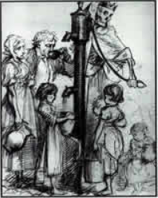

Deaths Dispensary
(George John Pinwell, 1866)

The Broad Street Pump, 2002
(handle removed)

John Snow's Map of the Cholera Epidemic, 1854
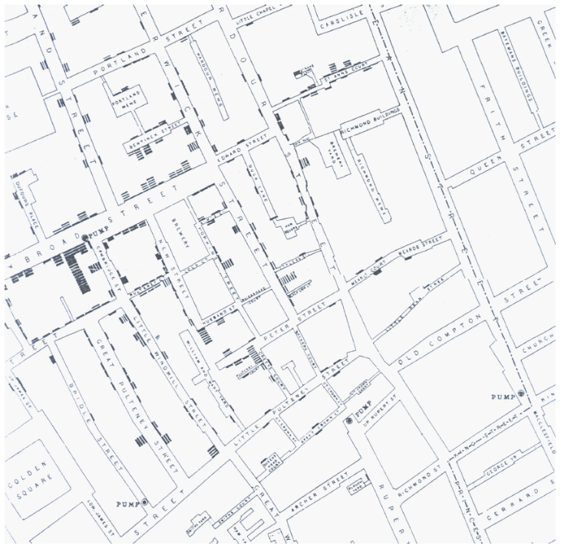
Map of Cholera Deaths (rectangles), water pumps (dots), and London streets generated by John Snow in 1854.

Center for Disease Control Map of the Same Epidemic, 2002
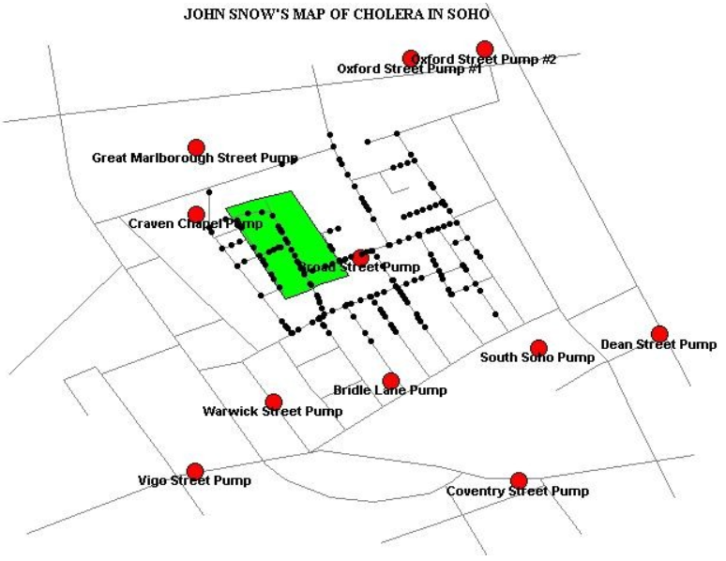
Map of Cholera Deaths (black dots), water pumps (red dots), and London streets generated by EpiMap Module of Epiinfo - a software package created by the Center for Disease Control and commonly used in epidemiology. https://llu.instructure.com/courses/926102/files/34766712
Next, he plotted (see maps above) the location of deaths due to cholera and from this map was able to show an unusally high number of cholera cases near certain water pumps. Specifically, at the intersection of Cambridge Street and Broad Street(see maps above), the number of cholera deaths was in excess of 500 during a 10 day period - a statistic that implicated the pump at Broad Street (see maps above), now known as the legendary "Broad Street Pump", as being contaminated. http://ije.oxfordjournals.org/content/31/5/920.full
Snow is credited with having the handle to the "Broad Street Pump" removed and containing the outbreak from that source. The pump and the handle that was removed from it have become symbols of effective epidemiology. Further discussion of this case study is given on the Center for Disease Control (CDC) website. https://llu.instructure.com/courses/926102/files/34766712
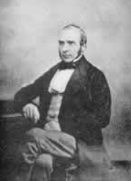
John Snow
Deaths from Cholera per 10,000 houses by source of water supply, London, 1854
Water Supply | # of houses | Deaths | Deaths per 10,000 houses
Southwark & Vauxhall | 40,046 | 1,263 | 315
Lambeth Co | 26,107 | 98 | 38
Other districts in London | 256,423 | 1,422 | 56

According to the article by Davey Smith, however, “Snow’s work did not emerge from a vacuum”. The cholera epidemics had engaged many investigators, and already in 1831 the Lancet stated that mankind was “the chief agent for its dissemination”. Into this picture also appeared political interests, economic interests and social factors. The new industrial capitalists was afraid of obstructions to their trades. Cholera was by many seen as a result of drunkenness, and “cholera is still an endemic disease in many poor parts of the world”. In the mid-19th century cholera amongst the poor was seen as a threat to the health of the wealthy. It was also a steady discussion whether cholera was a unifactorial or multifactorial disease, and Snow has been viewed as the convinced unifactorialist, who thought multifactorial causation “a metaphysical abstraction assumed to account for the facts”. Snow seemed to be, in a more general way, critical to approaches that attributed disease to general aspects of the environment. To him it was unhelpful to attribute cholera to socio-environmental factors, like poverty, because poor and rich would both get the disease if exposed to the cholera “poison”. However, according to Smith, “missing from this reasoning is the fundamental insight of social epidemiology, that to influence disease levels in populations, the determinants of population levels of disease need to be addressed, not the potentially different determinants of who gets the disease when a population is subject to a homogenous environment”.
Reference:
- Smith GE. Commentary: Behind the Broad Street pump: aetiology, epidemiology and prevention of cholera in mid-19th century Britain. Int J Epidemiol. 2002;31:920-932. http://0-ije.oxfordjournals.org.catalog.llu.edu/content/31/5/920.full OR:
http://0-ije.oxfordjournals.org.catalog.llu.edu/content/31/5/920.full.pdf+html

Students may access articles through the Loma Linda University Library:

http://www.llu.edu/library/index.page?rsource=library.llu.edu/

Please select the one best answer for each question.

- Note the difference in frequency of cholera deaths between the water companies. This suggest that the determinant of the cholera deaths was:

  - An infective agent mainly distributed through the water supplied by the Lambeth company
  - Drunkenness
  - An infective agent randomly distributed in nature
  - Associated with water supplied by the Southwark and Vauxhall companies
  - A “poison” homogenously distributed in the environment

- Note the distribution of cholera deaths around each of the water pumps on the Snow's maps. This suggests that cholera was:

  - Distributed equally through the water supplied by several street pumps
  - A disease with multifactorial causes and with socio-economic determinants
  - An infectious disease associated with water from the Broad Street pump
  - An infectious disease that has no environmental determinants
  - Caused by an infective agent distributed partly through the water supplied by the Broad Street pump

- Today cholera is not a major problem in developed countries, but the disease is still endemic in many other parts of the world. All of the reasons below for the low risk in developed countries is true, EXCEPT:

  - Access to clean water
  - Access to not-contaminated air
  - Access to nutritious food
  - Access to uncrowded housing
  - Access to knowledge of the disease etiology

- Vibrio Cholerae is a necessary agent to produce cholera. Below are listed factors that may impact who gets the disease in an exposed population, or the severity of the disease or its outcome. Which factor listed is not correct?

  - Marital status
  - Genetics
  - Immune status
  - Sanitation
  - Water supply

