Epidemic of Toxic Shock Syndrome during the 1980's
Toxic Shock Syndrome (TSS) is a very rare, life threatening illness caused by toxins produced by certain strains of Staphylococcus aureus and group A streptococci, both gram positive bacteria. Staphylococcus TSS occurs secondary to a localized infection with an incidence of 0.3-0.5/ 100,000 and a case-fatality ratio of about 3%. Streptococcal TSS is caused by an invasive (i.e. increased tendency to spread) infection with an incidence of around 2-4/100,000 and a mortality of about 50%. TSS received widespread attention in the United States during the early 1980's when an unusually high number of healthy young women from several states died of TSS. Subsequent investigation of these cases revealed that most of the TSS cases were women who were menstrual and using a specific type of superabsorbent tampon.

Some initial studies correlated the introduction of the Rely tampon with the steep rise in TSS cases and in 1980, Procter and Gamble removed this tampon from the market. Shortly after its removal, the number of cases dropped steadily. This is depicted in the figure below.

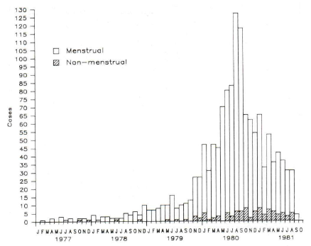

Fig. 1. Histogram of TSS cases(1977-1981) plotted by menstrual status and indicators of introduction and removal of the Rely tampon from the market (Reingold, 1982)

When TSS became recognized as a widespread problem in 1980, the Centers for Disease Control (CDC) organized a nationwide surveillance system, using specific criteria for case definition. A pattern soon emerged with differences in age distribution between menstrual and non-menstrual cases, possibly caused by age-dependent patterns of variations in tampon-usage and in susceptibility to TSS. A racial distribution was also observed with a marked predominance of whites among those with menstrual TSS, possibly caused by non-whites having natural immunity, having less access to medical care, difficulty recognizing erythroderma (redness and scaling of the skin) in dark-skinned subjects, and small numbers of such persons in states with the most active surveillance system. However, the proportion of non-menstrual TSS in non-whites was similar to their representation in the US population, indicating that menstruation-related differences more likely was the cause. A disproportionate geographic distribution of TSS was reported, and this was thought to be due in part to differing levels of interest among state health departments and local clinical investigators. The reporting of TSS may further have been affected by the ability to recognize the disease, by changes in the surveillance system, by publicity, and by litigation.
Some of the early studies examining why the Rely tampon may have been causal in TSS indicated that properties of the superabsorbent fiber in this tampon may promote the production of bacterial toxins (Mills, 1985). This mechanism was further supported by the drop in TSS cases during 1981-1986 that correlated with FDA regulations on fiber absorbency. This is depicted in the figure below.
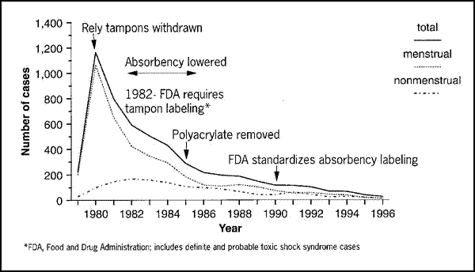
Fig. 2. Histogram of TSS cases (1980-1996) plotted by menstrual status and indicators such as Rely tampon removal from the market, and further FDA regulation on fiber types (CDC).

References
Reingold AL, Hargrett NT, Shands KN, Dan BB, Schmid GP, Strickland BY, Broome CV. Toxic shock syndrome surveillance in the United States, 1980 to 1981. Ann Intern Med. 1982 Jun;96(6 Pt 2):875-80. http://0-annals.org.catalog.llu.edu/article.aspx?articleid=695680 or:
http://0-search.ebscohost.com.catalog.llu.edu/login.aspx?direct=true&db=aph&AN=7009383&site=ehost-live&scope=site
Mills JT, Parsonnet J, Tsai YC, Kendrick M, Hickman RK, Kass EH. Control of production of toxic-shock-syndrome toxin-1 (TSST-1) by magnesium ion. J Infect Dis. 1985 Jun;151(6):1158-61.
Students may access articles through the Loma Linda University Library:
http://www.llu.edu/library/index.page?rsource=library.llu.edu/
Please select the best one answer(s) for each question
- What basic clinical and epidemiological tool was necessary to diagnose TSS?

  - Physical exam to assess fever, hypotension, rash, desquamation, and other abnormalities
  - Blood culture to identify Staphylococcus aureus bacteremia
  - ELISA (enzyme-linked immuno assay) to test for antibodies towards Staphylococcus aureus
  - Case definition criteria
  - Determine who was using tampons

- What systematic approach was necessary to get the data needed to understand the size of the problem and the etiology (cause) behind it after the diagnosis was made?

  - The evolution of a nationwide surveillance system
  - Disease history with emphasis on menstruation and tampon use
  - Describe population at risk
  - Measure the frequency of tampon brand use
  - Make hypothesis of the etiology of TSS and test them in experimental studies

- Differences in age distribution was observed between menstrual cases and non-menstrual cases. While 65% of menstrual cases were in women <25 years old, this age group had only 40-43% of the tampon users. Which factor(s) could explain these differences?

- Recent child birth
- Tampon-usage patterns according to age
- Open wounds
- Age-dependent susceptibility to TSS
- Tampons marketed specifically for overnight use

- Racial differences in the distribution of TSS was observed. Which one of the following factors could not explain these differences relating to non-whites?

- Less access to medical care
- Redness and scaling of the skin is difficult to recognize in dark-skinned subjects
- Menstruation-related differences was not likely between black and white women
- Small number of non-whites in states with the most active surveillance systems
- Natural immunity

- Note the marked changes in frequency and distribution of TSS cases during 1977 to 1996 (Fig.1 & Fig.2). Successive decrease in TSS cases with successive changes in design and labeling of the tampons suggests that the factors that was changed probably was causally related to TSS. Which factor(s) below is (are) correct?

- Rely tampon withdrawn
- Early treatment of TSS and not reporting cases
- Absorbency lowered
- Required labeling of tampons
- Polyacrylate removed
- FDA standardized absorbency labeling

