The Ebola epidemic
Ebola is a French adaptation of “Legbala” (“white waters”), the name of the Ebola river in Zaire in the local Ngbandi language. Ebola virus disease (EVD) was first identified in 1976. It is caused by an RNA virus in the filovirus family, consisting of five separate species, four of which are known to cause disease in humans. EVD is feared because no effective treatment or vaccine is available, and the fatality rate is 25-90%. The only remedy available to contain this disease is quarantine of suspected EVD patients. This requires highly specialized facilities with personell that understand the risks, and that is especially trained to take care of such patients. Such facilities are available in many resource-rich countries. However, when thousands of people are infected, whole communities needs to be quarantined. This may be close to impossible. Earlier outbreaks have occurred in rural regions and have not been widespread, but have been limited to specific geographic areas. Such outbreaks have been contained through routine public health measures intended to break the virus transmission chain, like case identification, contact tracing, patient isolation and quarantine.
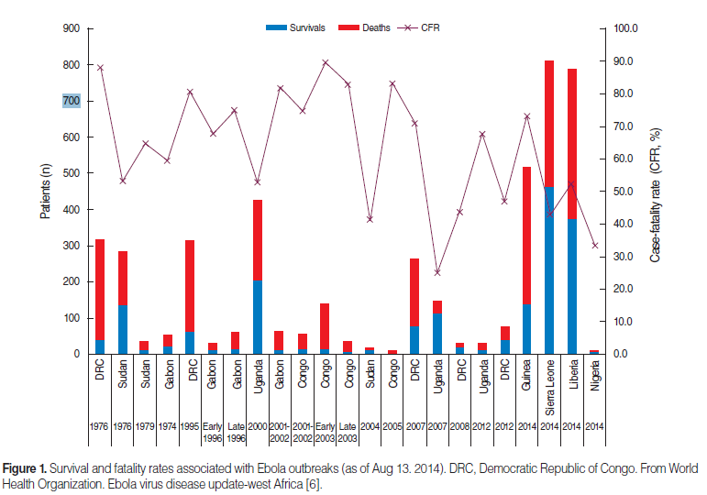
Fig. 1 (Moran Ki, 2014) shows survival and fatality rates in an Ebola outbreak in Congo as of August 2014.
In December, 2013 started the worst known outbreak of EVD in Guinea, with spread to Liberia and Sierra Leone, and with cases doubling every 15-40 days. By August 31, 2014 a total of 3,685 cases had been reported in West Africa with a case fatality of less than 60%. By March 2015 the death toll had past 10,000. About 60% of EVD cases in Guinea were associated with funeral proceedings that included bathing of the dead before burial. Outbreaks are believed to originate from animal reservoirs, with the most probable being a fruit bat, which is also thought to transmit to monkeys, gorillas, chimpanzees, forest antelopes and porcupines. Studies have indicated that transmission of the virus is dependent on direct contact (through broken skin or mucous membranes) with bodily fluids like feces, vomit or blood from infected animals or humans. However, the virus is not transmitted by causal contact or through the air.
Early symptoms are unspecific, often mimicking a flu with sudden onset of fever, profound fatigue, muscle pain, headache and sore throat. However, this is followed by vomiting, diarrhea, a maculo-papular rash, symptoms of impaired kidney and liver function. Then, in some cases, internal and external bleeding.
The West African countries affected are resource-poor, and struggling to cope with endemic diseases (e.g. malaria) and other major health challenges. The borders in this part of Africa are porous, with people constantly moving between countries. The health care infrastructure is inadequate, with few health care workers and scarce supplies (i.e. personal protective equipment). Transmission of EVD is facilitated by traditional practices (i.e. bathing of corpses before burial), and by political conflicts and war that has left the population distrustful of people representing the government (i.e. health professionals). Finally, the epidemic spread to cities, making it very hard to trace contacts.
In order to deal with EVD we need to investigate and understand the epidemiologic characteristics of the disease. The incubation period is 2-21 days, but typically lasts 5-7 days. However, we need to learn more about the latent period (latency=delay between exposure and disease manifestations), the transmission period, which starts when symptoms appear, and the transmission pathways. The virus may still be found in the patient’s body fluids for an extended period after recovery, and the patient remain infectious as long as the virus is present in their blood and body fluids, including semen and breast milk. We also need to better understand the pathogenicity (i.e. the capacity to cause disease in an infected host) of EVD, its virulence (i.e. disease severity) and why disease fatality varies between EVD strains.

References
Ki M. What do we really fear? The epidemiological characteristics of Ebola and our preparedness. http://dx.doi.org/10.4178/epih/e2014014
OR: http://e-epih.org/upload/pdf/epih-36-e2014014.pdf

Fauci AS. Ebola-Underscoring the Global Disparities in Health Care Resources. http://0-www.nejm.org.catalog.llu.edu/doi/full/10.1056/NEJMp1409494

Meltzer MI, Arkins CY, Santibanez S, et. al. Estimating the Future Number of Cases in the Ebola Epidemic – Liberia and Sierra Leone, 2014-2015. MMWR 2014;63(Suppl-#) (early release). http://www.cdc.gov/mmwr
Students may access articles through the Loma Linda University Library:
http://www.llu.edu/library/index.page?rsource=library.llu.edu/

For each question below, please select the best answer(s).
- Where does the name “Ebola” stem from?

- Name of a village in The Democratic Republic of Congo
- Name of a river in Zaire
- Name of a county in Congo
- French adaptation of “Legbala” (“white waters”)
- None of the above

- From which one source does Ebola most likely originate?

  - A virus reservoir in yeast
  - A rodent reservoir only
  - An animal reservoir
  - A virus reservoir in migrating birds only
  - A virus reservoir in freshwater fish
  - None of the above

- What is probably the one most natural host (source) of the Ebola virus?

  - Porcupines
  - Rats
  - Forest antelopes
  - Fruit bats
  - Yeast
  - None of the above

- What other animals do we believe may also transmit the Ebola virus?

  - Monkeys
  - Porcupines
  - Chimpanzees
  - Antelopes
  - Gorillas
  - None of the above

- What is the range of case fatality proportions (often called case fatality “rates”, or just fatality “rates”) in outbreaks of the four species of the Ebola virus that is known to cause disease in humans?

  - 25-80%
  - 35-55%
  - 55-90%
  - 25-75%
  - None of the above

- What is the case fatality proportion of the present outbreak?

  - Less than 60%
  - Less than 50%
  - Above 60%
  - 35-50%
  - About 90%
  - None of the above

- Ebola has become such a large problem in Western Africa and so difficult to prevent because of all of the following reasons, EXCEPT which one?

  - Countries affected are resource-poor
  - Borders are porous, with people constantly moving between countries.
  - Inadequate health care infrastructure, with few health care workers and scarce supplies
  - Abandoned traditional practices
  - Countries affected struggle to cope with endemic diseases and other major health challenges
  - Epidemic spread to cities are complicating tracing of contacts
  - Political conflicts and war has left the population distrustful of governing officials and authority figures, such as health professionals

- Earlier outbreaks have been contained through “routine public health measures”. All of the following measures have been used to break the chain of virus transmission, EXCEPT which one?

  - Case identification
  - Occupational EVD cluster identification
  - Contact tracing
  - Patient isolation
  - Quarantine

- It is believed the Ebola virus transmits between animals and humans, and between humans, through all of the following vehicles, EXCEPT which one?

  - Direct contact with tissue or blood of an infected animal or patient
  - Direct contact with feces or vomit of an infected animal or patient
  - Direct contact with contaminated air
  - Direct contact with contaminated fomites
  - Direct contact with breast milk of an infected animal or patient
  - Direct contact with semen of an infected animal or patient

- The current Ebola epidemic started in Guinea in December 2013. What specific traditions was associated with most of the cases in Guinea?

  - Having sex with a virgin to get rid of possible HIV infection
  - Trusting witch doctors to diagnose and heal the sick
  - Having sex with young girls who need regular infusion of semen to become beautiful
  - Funeral proceedings
  - Having extramarital sex because the wife is breastfeeding

- All of the following are epidemiological characteristics of Ebola that we are today interested in investigating, EXCEPT which one?

- Toxigenicity
- Incubation period
- Latent period
- Transmission period and pathway
- Pathogenicity
- Virulence
- Fatality

