EPDM 509 - Review for midterm exam

Surveillance: Active (SEER program), Passive (health providers), Sentinel (“first case”),
Special (NHANES)

External and internal validity: Definitions
External: extent to which study results are applicable to the general population
Internal: extent to which the study reflects the “truth” about the study population

Prevalence and Incidence, and how they are dependent on each other
Prevalence ≈ Incidence * Duration

Effect of Prevalence on predictive value: Low Prevalence (<10%): PV+ high, PV-
lower. High Prevalence (>40-50%): PV+ high, PV- lower.

Serial testing and parallel testing: effects on sensitivity and specificity
Serial (sequential) testing decreases sensitivity, increases specificity
Parallel (simultaneous) testing (shotgun) increases sensitivity

Epidemic, Endemic, Pandemic

Proportion (A/A+B), Rate (A/(A+B)T and Ratio (A/B)

Lead time bias: Increase in survival as measured from detection of a disease to death,
without lengthening of life.

Length biased sampling = Length time bias: Prognostic selection (of survivors).

Characteristics of a good screening program

Disease outbreaks: Point source, Common source, Propagated

Randomized Controlled Trial (RCT): Random assignment is intended to make the
control and intervention groups similar at the start of a study in order to reduce
selection bias.

Designs: Parallel, Cross-over, Factorial, geographic, historic

Explanatory trials -testing efficacy (does the treatment work when actually taken)

Pragmatic trials – testing effectiveness (does treatment work under normal conditions)

Attack rate (%): (# of new cases of the disease/total # at risk) x 100
In a food-borne epidemic you may calculate the attack rate for each food item to find the source (usually one) of the outbreak. Expect contamination of other food items from the source, and that people do not remember exactly what they ate.
Sensitivity, Specificity, PV+, PV-, accuracy, false positive/negative “Rate”.

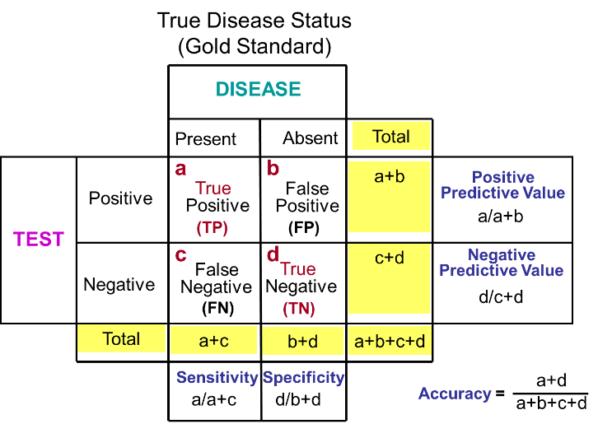

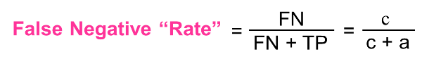

For screening purposes, how do you use highly sensitive or highly specific tests?

First: Use a highly sensitive test = low cut-off (↑FP – false positives)
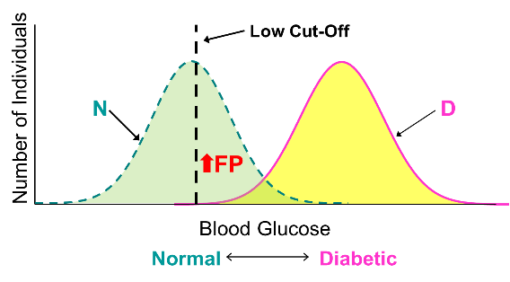
Second: Use a highly specific test = high cut-off (↑FN – false negatives)
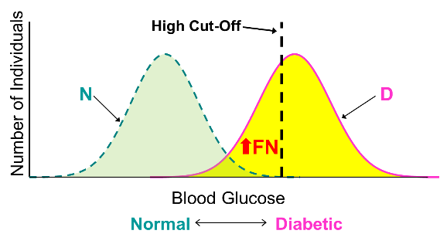

Type I error: Rejecting the null hypothesis (H₀) when it is true.
Type II error: Rejecting the alternative hypothesis (H_{a}) when it is true.

AR = RD (attributable risk/risk difference) and ARP (attributable risk percent)

RR (relative risk = rate ratio) = Risk exposed/Risk unexposed = Incidence
exposed/incidence non-exposed (cohort studies)

Mortality measures:
Crude mortality = # of deaths in a year/total population
Case-fatality rate (%) = (# individuals dying during a specified period of time after disease onset or diagnosis/# of individuals with the specified disease) x 100

Prevention: Primary, Secondary, Tertiary

Adventist Health Study (AHS): Questions on main issues (cancer, longevity, nut intake)
among Adventists.

Experimental studies – Blinding:
- Single - Subjects/patients
- Double - Subjects/patients + clinicians/caretakers
- Triple - Subjects/patients + clinicians/caretakers + assessors (of outcome)

Extra credit Questions:

Proportionate Mortality = # of deaths from a specific cause in a defined year / total
deaths in same year.

Cause-specific mortality = (# of deaths from a specific cause in one year / Total
population at midyear) x 1,000

Infant mortality “rate” = (# of deaths in a year of children less than 1 year of age /
number of live births in the same year) x 1,000

