EPDM 509 - Review for final exam

Confounding.
- How it biases the results: Mixes up the effect(s) of the exposure on the outcome.
Can even change the apparent direction of an effect, biasing the result(s) toward or away from the null hypothesis.
- How it may be controlled:
  - Study design:
    - Selection (of study groups)
    - Matching
    - Randomization (RCT)
  - Analyses:
    - Stratification
    - Multivariate Regression
    - Adjustment
- How it is defined – it is:
  - a known risk factor for the outcome
  - associated with (but not a result of) the exposure factor
  - not an intermediate step in the causal pathway between exposure and outcome.

External and internal validity: Definitions
External: extent to which study results are applicable to the general population
Internal: extent to which the study reflects the “truth” about the study population

Sensitivity, Specificity, PV+, PV-, accuracy, false positive/negative “Rate”.

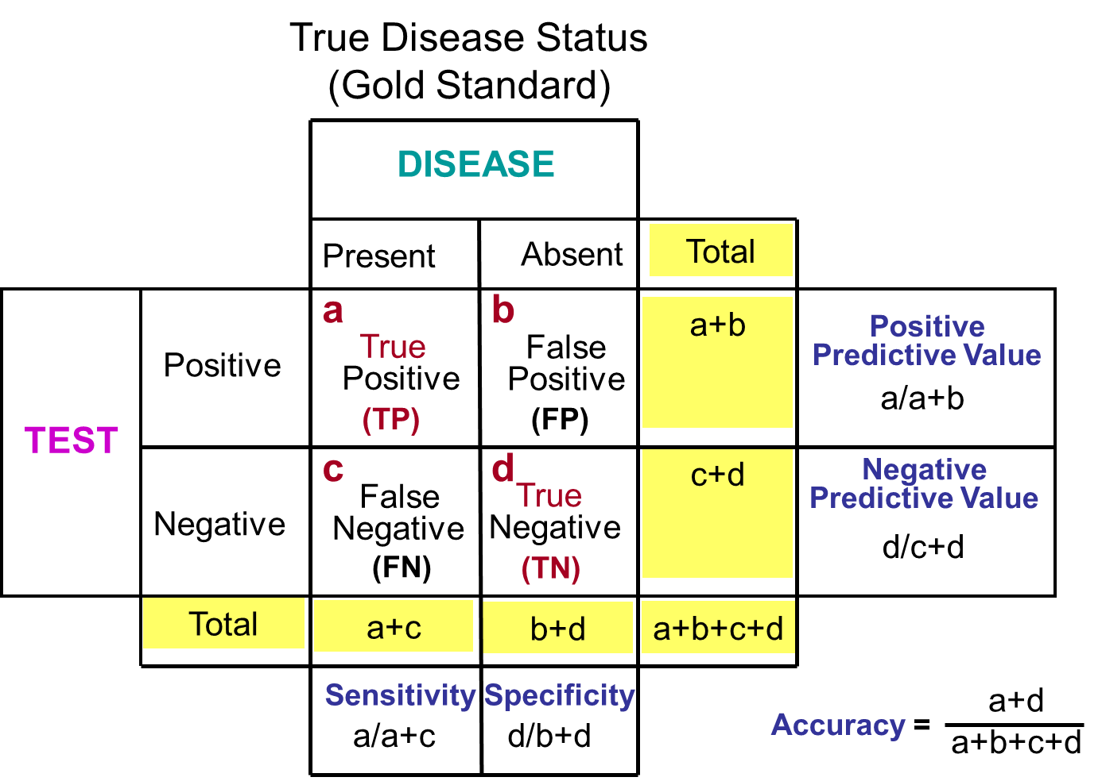

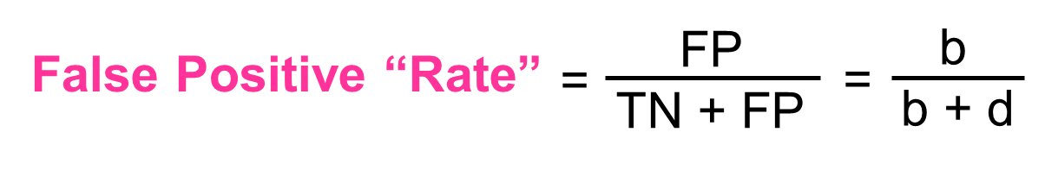

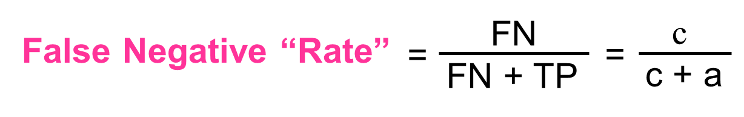
For screening purposes, how do you use highly sensitive or highly specific tests?

First: Use a highly sensitive test = low cut-off (↑FP – false positives)
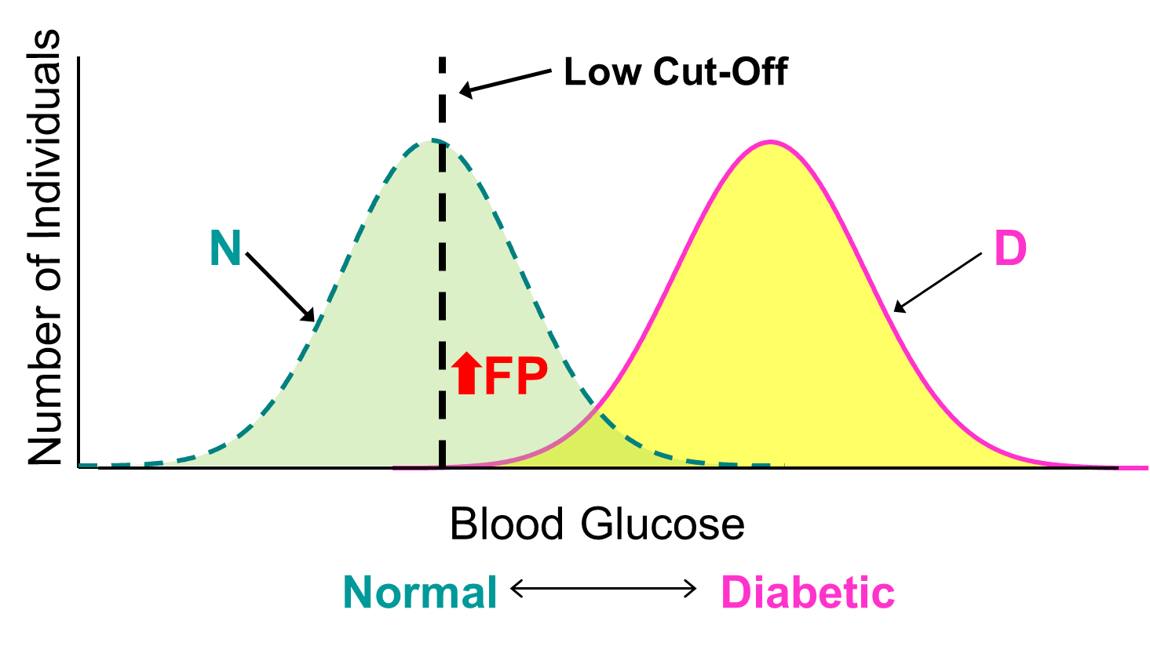
Second: Use a highly specific test = high cut-off (↑FN – false negatives)
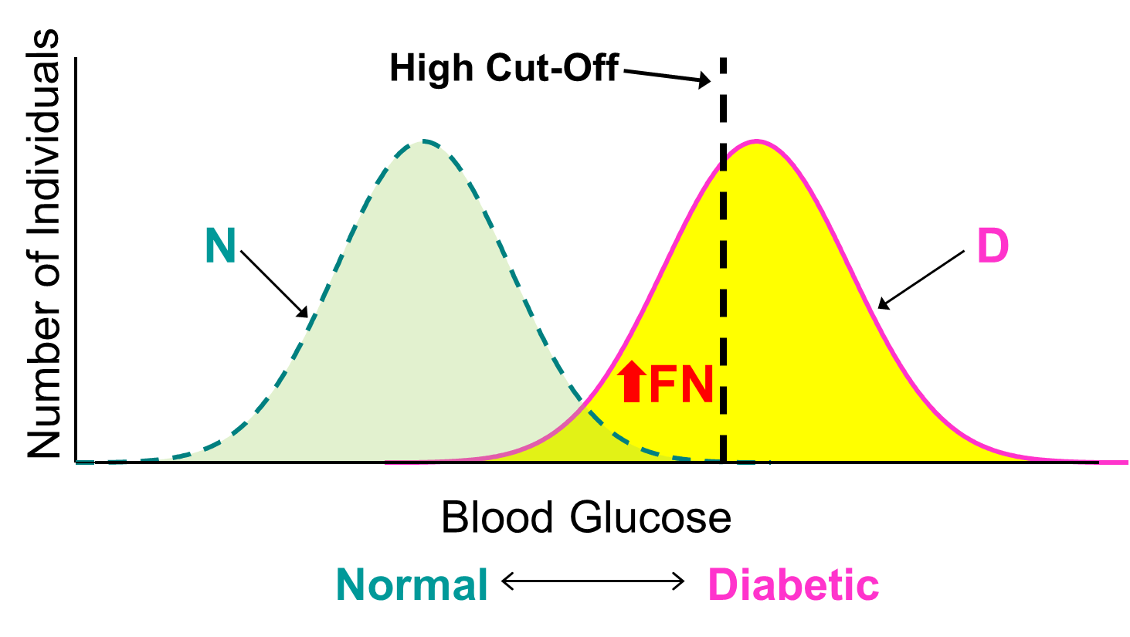

Prevalence and Incidence, and how they are dependent on each other
Prevalence ≈ Incidence * Duration

Ecologic fallacy: when a risk factor (exposure) and disease (outcome) are associated at
the population level, but not at the individual subject level.

Serial testing and parallel testing: effects on sensitivity and specificity
Serial (sequential) testing decreases sensitivity, increases specificity
Parallel (simultaneous) testing (shotgun) increases sensitivity

Migrant studies: Why do? Separate the effects of nature (genetics) and environmental
factors (lifestyle, diet)

Epidemic, Endemic, Pandemic

Epidemic curves, Common source, Point source and Propagative epidemics

Proportion (A/A+B), Rate (A/(A+B)T and Ratio (A/B)

Definitions, selection (disease or exposure status), advantages and disadvantages of:
Case-control studies, Cohort studies (prospective/concurrent, retrospective/ historical), Experimental (clinical) studies (randomized, controlled or not), Ecologic studies. Case series. Community trials.
What are the designs suitable for?

Biases: Selection, reporting, recall, measurement, misclassification (differential, non-
differential), length time bias (prognostic selection), lead-time bias (increase in survival as measured from detection of a disease to death, without lengthening of life). Bias = Systematic error, results in low accuracy (ability of the test to correctly classify people as diseased or not diseased), and low validity (measure is not “at target”).

Random Error: Low precision (reliability) of the measure because of low reproducibility (results randomly scattered, not “clustered”)

Type I error: Rejecting the null hypothesis (H₀) when it is true.
Type II error: Rejecting the alternative hypothesis (H_{a}) when it is true.

Study designs: Parallel, Cross-over, geographic, historic

Explanatory trials -testing efficacy (does the treatment work when actually taken)

Pragmatic trials – testing effectiveness (does treatment work under normal conditions)

Causation: Necessary, sufficient and component causes of disease. Initiators and promoters as component causes.

Hill’s criteria for causal inference (Dose-response, biologic plausibility, strength of
Association, consistency of findings, time-sequence, analogy)

Attack rate (%): (# of new cases of the disease/total # at risk) x 100

RR (relative risk = rate ratio) = Risk exposed/Risk unexposed = Incidence
exposed/incidence non-exposed (cohort studies)

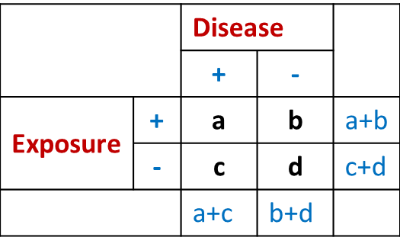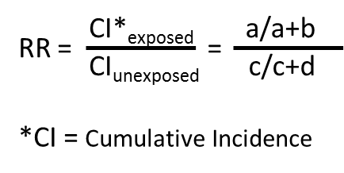

OR (Odds Ratio) = the # of ways the event can occur to the # of ways the event cannot
occur. NB! cross product in 2x2 table. OR used in case-control studies where you do not have incidences, and therefore cannot calculate RR.

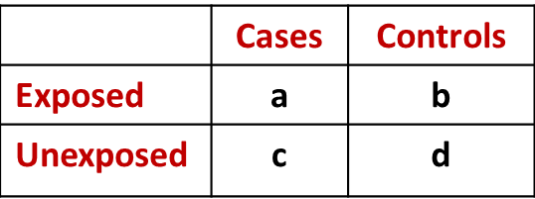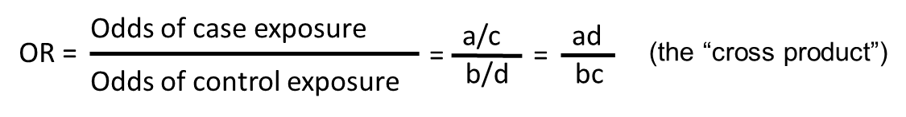

Mortality measures: Crude mortality = # of deaths in a year/total population
Case-fatality rate (%) = (# individuals dying during a specified period of time after disease onset or diagnosis/# of individuals with the specified disease) x 100

Adventist Health Study (AHS): Questions on main issues (cancer, longevity, nut intake)
among Adventists.

Experimental studies – Blinding:
- Single - Subjects/patients
- Double - Subjects/patients + clinicians/caretakers
- Triple - Subjects/patients + clinicians/caretakers + assessors (of outcome)

Interaction (effect modification): An outcome (disease) has seldom only one cause. Therefore, we need to know how multiple factors interact in causing a disease. When the effect of one known risk factor on disease outcome is modified by one or more other known risk factors, we will have one of the following forms of interaction:
- Additive: When the effect on risk of disease of one causal factor can be estimated independent of the presence or absence of another causal factor. The risk of disease is the sum of the excess risks (using Incidence as effect measures) associated with each of the factors.
- Antagonistic (negative): The risk of disease with the presence of two known causal risk factors is less than the sum of the excess risks (using Incidence) associated with each of the factors.
- Synergistic (positive): The risk of disease with presence of two known causal factors is greater than the sum of the excess risks (using Incidence) associated with each of the factors.
- Multiplikative: The risk of disease with presence of two factors is the product of the Relative Risks (RR’s are used as effect measures) associated with each of the factors.

